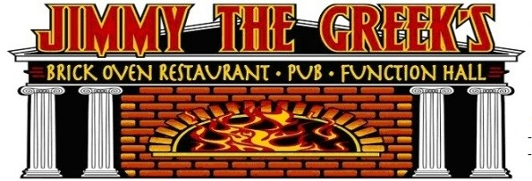
JUNE 2022 : HELLO SUMMER!
WATCH THE CELTS HERE!!!

 | EVERY MON 7p  7pm | MARGARITA  MADNESS!!!  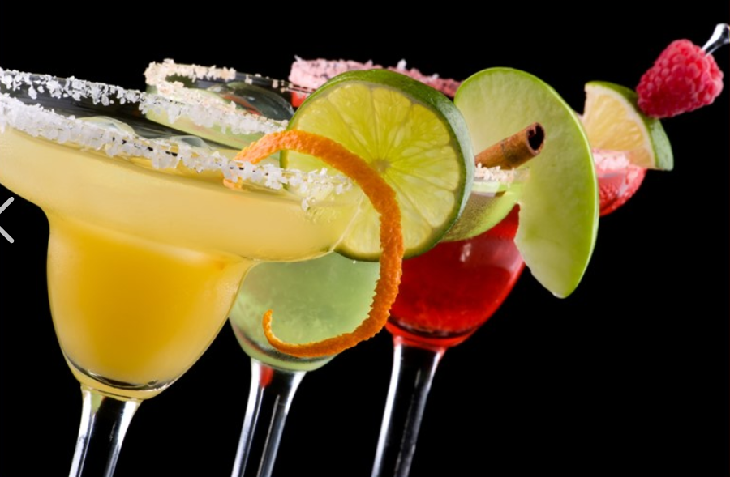  $7 Margs | 1 OPEN MIC NT  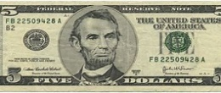  ALL DRAFTS $5 | 2 CELTS GAME 1 | 3 TGIF HAPPY HR  KRIS HYPE  7pm | 4  DAVE BAILIN  7pm
5 Seltzer Sunday  $4 SELTZERS | 6  7pm  SHIPYARD SPEC | 7 MARGARITA  MADNESS!!!  $7 Margs | 8 OPEN MIC NT | 9 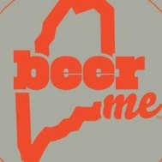  Local Flavah!  $5 Maine Crafts  LIVE MUSIC TRIV.  JUSTIN CARVER 530 | 10 TGIF HAPPY HR  Joan  Kennedy 5 | 11  mATT FOURNIER  6pm
12 Seltzer Sunday  $4 SELTZERS |  | 14 MARGARITA  MADNESS!!!  $7 Margs | 15 OPEN MIC NT  Drinking w LINCOLN  All Drafts/Well $5 | 16 | 17 TGIF HAPPY HR  THE BARMEN  (IRISH)  7 pm | 18  TIKI THOM  On the patio  530 pm
19 Seltzer Sunday  $4 Hard Seltzers | 20  7pm  SHIPYARD SPEC | 21 MARGARITA  MADNESS!!!  $7 Margs | 22 OPEN MIC NT  Drinking w LINCOLN  All Drafts/Well $5 | 23  Local Flavah!  $5 Maine Crafts  LIVE MUSIC TRIV.  JUSTIN CARVER 530 | 24 TGIF HAPPY HR  CHRIS  JAMES  7pm | 25  BILLY BILLY  On the patio  530 pm
26  Seltzer Sunday  $4 Hard Seltzer | 27  7pm  SHIPYARD SPEC | 28 MARGARITA  MADNESS!!!  $7 Margs | 29 OPEN MIC NT  Drinking w LINCOLN  All Drafts/Well $5 | 30  Local Flavah!  $5 Maine Crafts  KARAOKE ON THE PATIO  6pm | TGIF HAPPY HR

